Task 6: Configure Azure Backup
What to do:
- Create a Recovery Services vault
- Create a backup policy with daily backups at 11:00 PM, retained for 7 days
- Enable backup for your VM using this policy
Acceptance Criteria:
- Recovery Services vault exists
- Backup policy shows daily backup at 11:00 PM, 7-day retention
- VM appears as a protected item in the vault

To create a Recovery Services vault:
- Sign in to the Azure portal.
- Search for Resiliency, and then go to the Resiliency dashboard.

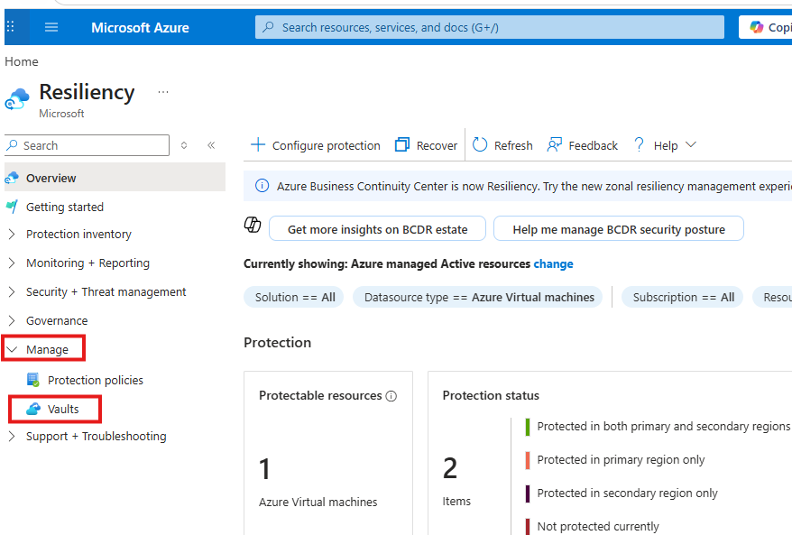

Click on manage>> on the Vault pane, select + Vault.
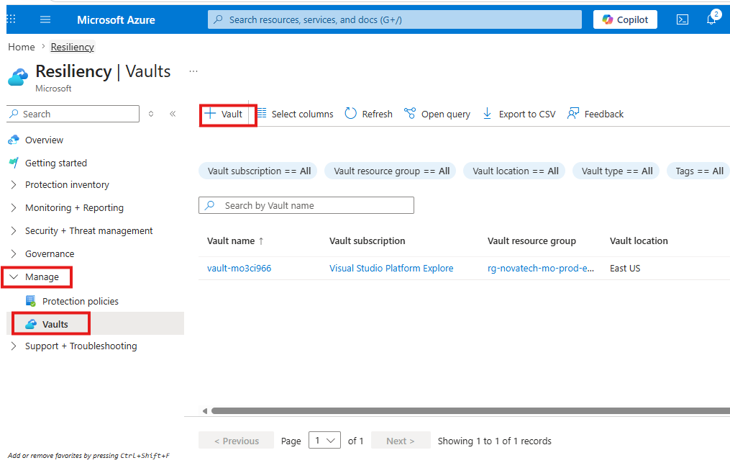
Select Recovery Services vault > Continue.
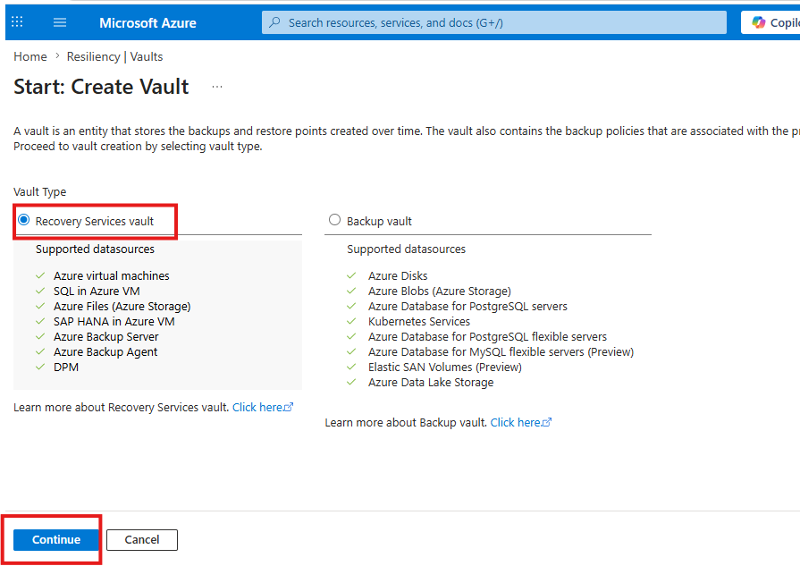

Enter the following values:
- Subscription: Select your Azure subscription.
- Resource Group: Select the previously created RG
- Name: Give the Valt a name.
- Region: Select an Azure location East US
After you provide the values, select Review + create.
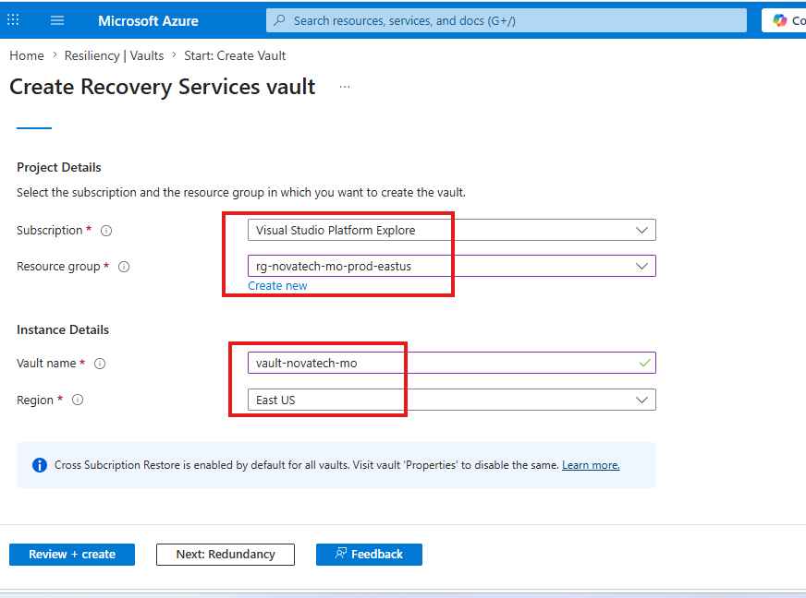

To finish creating the Recovery Services vault, select Create.
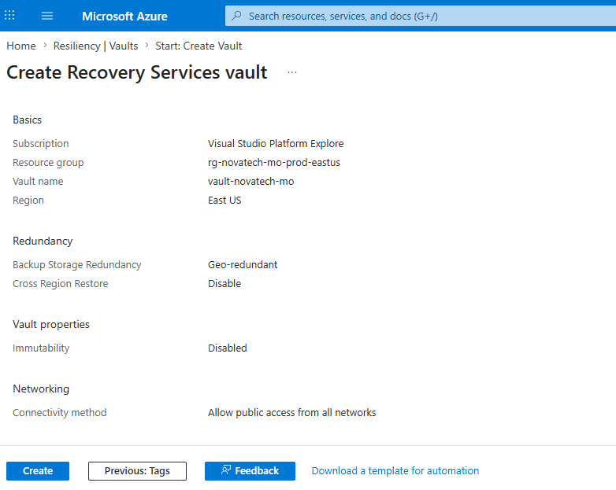

Apply a backup policy
To apply a backup policy to your Azure VMs, follow these steps:
- Go to Resiliency and select + Configure protection.
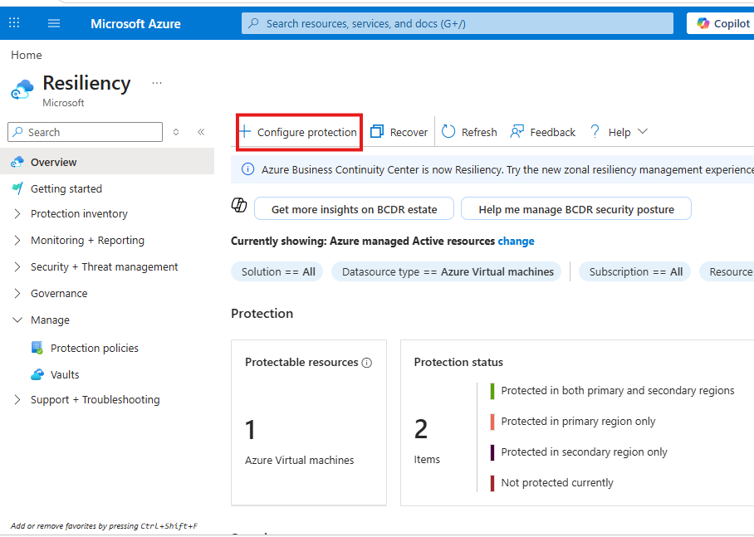
- On the Configure protection pane, select Resource managed by as Azure, Datasource type as Azure Virtual machines, Solution as Azure Backup, and then select Continue.
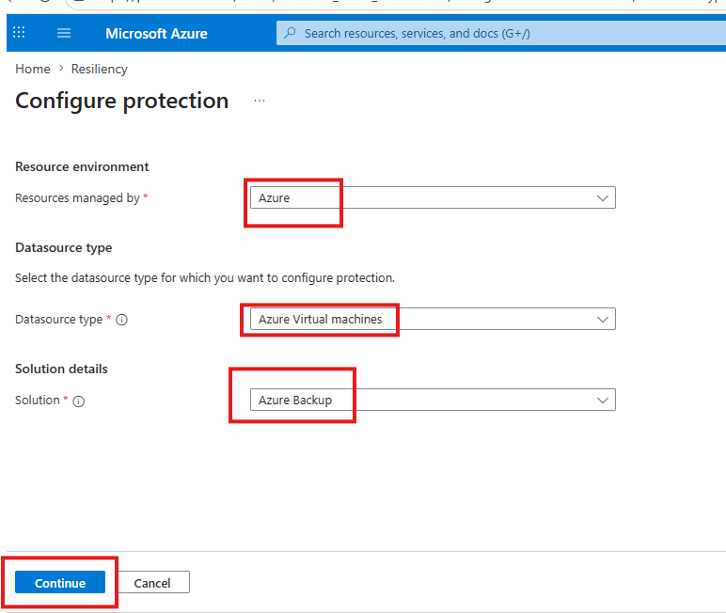
- On the Start: Configure Backup pane, select Azure Virtual machines as the Datasource type and select the vault you have created. Then select Continue.
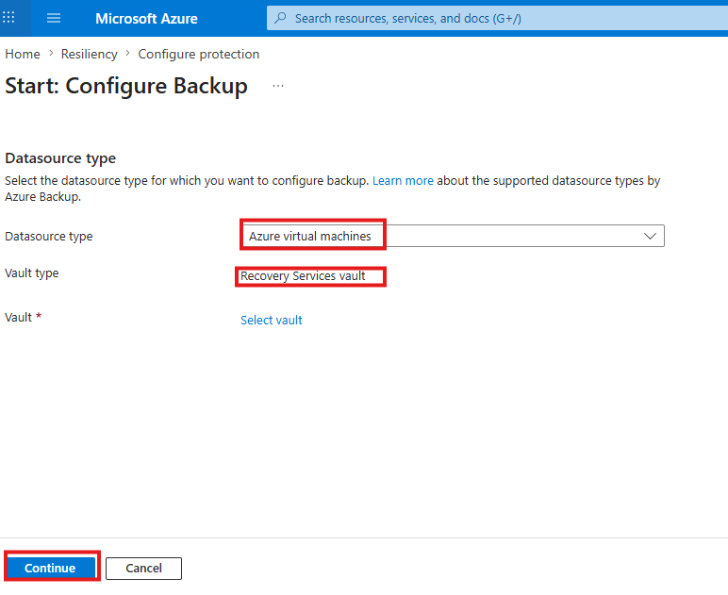
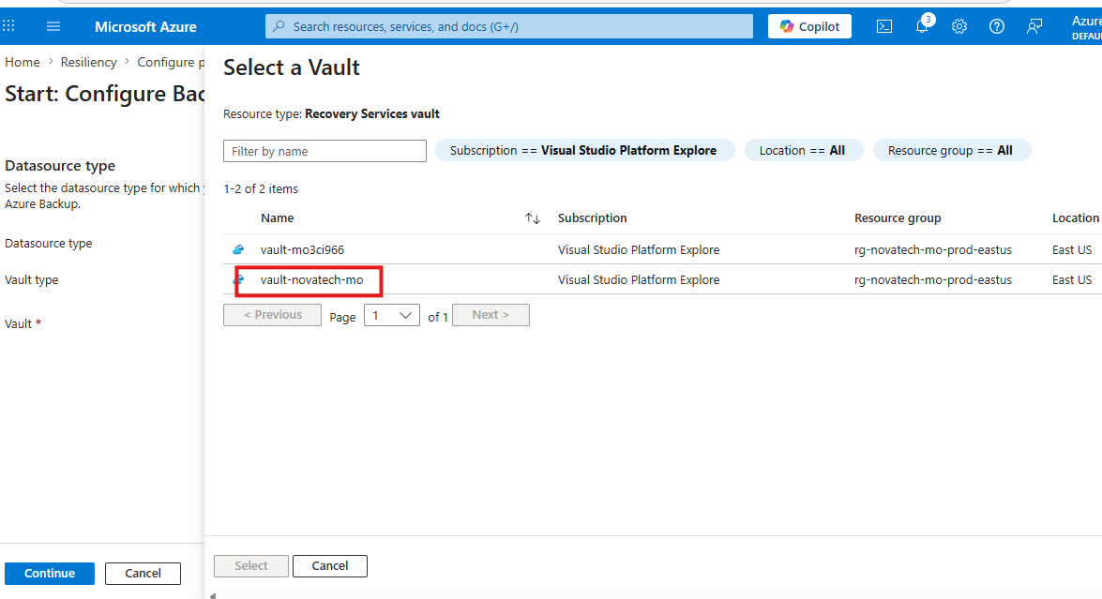
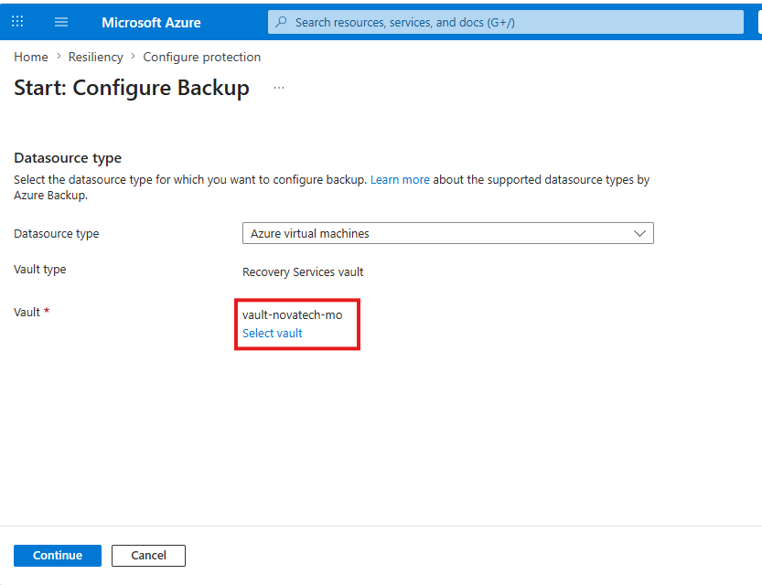
Backup policy shows daily backup at 11:00 PM, 7-day retention
- On the Configure backup pane, select the Policy sub type as Enhanced
select Create New,
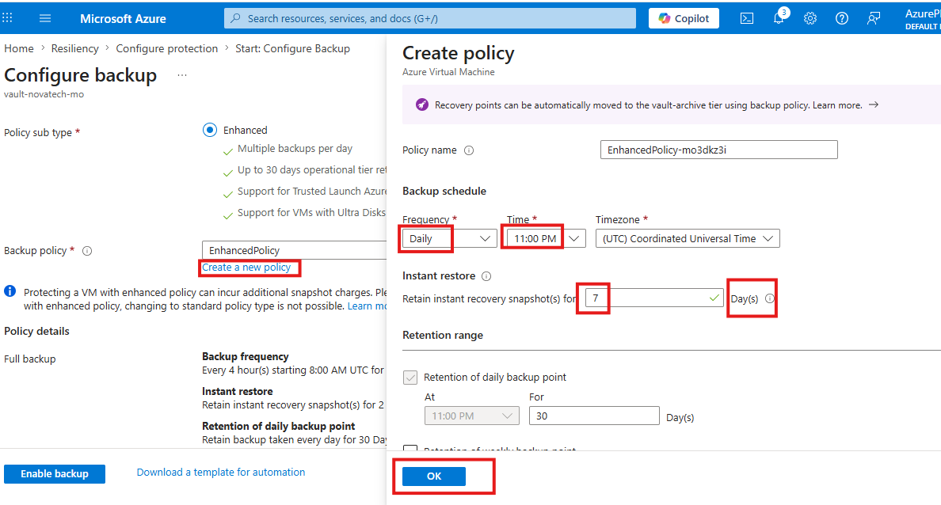

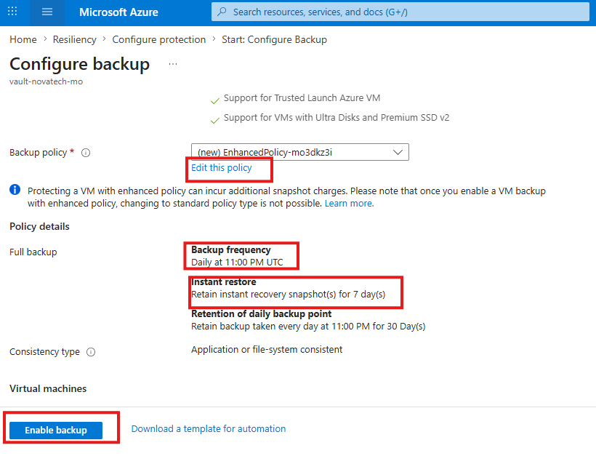
VM appears as a protected item in the vault
The Select virtual machines blade will open. Select the VMs you want to back up using the policy. Then select OK.
